HABITS: A History Aware Based Wi-Fi Indoor Tracking System

Eoghan Furey

Supervisors: Dr. Kevin Curran, Prof. Paul Mc Kevitt

Faculty of Computing and Engineering, University of Ulster, Magee College, Derry.

Abstract
Location Aware Computing (LAC) has become an important area in both academia and industry. The need for computing devices to have knowledge of their surroundings has many applications in the modern world. These range from medical and military to logistical and social. The positioning algorithms that are used are still in a period of rapid innovation with a necessary trade off between accuracy and time consuming calibration. This unique study will consider movement history along with antenna EIRP (Effective Isotropic Radiated Power) as a means of improving Wi-Fi indoor location estimates. A new algorithm for use in 802.11 Wi-Fi networks will be developed with two main aims. Firstly, it will be able to learn from the movement history of the mobile device. This knowledge should improve accuracy when signals are scarce. Secondly it will use prior knowledge of the building structure and of antenna EIRP to differentiate between room and floors. The Algorithm will be run on the PlaceLab software platform. When developed, this new algorithm will be tested in a creative technologies software application, where wireless self location is critical, such as mobile gaming, home automation & entertainment, tourist activity or security.

Keywords: Location Aware, Context Aware, Ubiquitous Computing, Pervasive Computing, Radio Location, 802.11, Wi-Fi, Positioning Algorithms, PlaceLab, Particle Filters, Fingerprinting, Bayesian networks.

1. Introduction

Over the past two decades a large number of commercial and research location systems have been developed (Hazas et al. 2004). Generally, these systems had one of two goals:

- Providing lower accuracy over a wide coverage area.
- Providing high accuracy (<30cm) in a small area.

Accuracy systems often require extensive infrastructure, many sensors and time consuming calibration. AT&T Cambridge’s Active Bats (Addlesee et al., 2001) system uses ultrasonic badges and requires one ultrasound receiver to be installed every square meter. Wide area coverage is most famously achieved by using the Global Positioning System (GPS). A constellation of low orbit satellites cover the earth’s surface. Unfortunately GPS does not work indoors and has limited success in big cities because of the ‘urban canyon’ effect. Mobile phone companies also have methods of triangulating the position of a user’s phone within a particular ‘cell’. E911/E112 requirements (Geer, 2001) from the US/EU mean that a phone’s location can now be discovered to within 100m in Europe and the United States. Microsoft’s Research RADAR system uses ambient 802.11 systems to estimate a user’s location. RADAR could have accuracy of up to 3 meters but requires calibrating every square meter of the site to be used. This research aims to improve upon existing work by taking users movement history into account. It will optimise Self location estimates on Wi-Fi enabled devices by introducing movement history and antenna EIRP (Effective Isotropic Radiated Power) into the algorithm. These will be used in conjunction with existing maps and plans of buildings. In a similar study carried out using GSM (Flynn et al., 2004) it was found that by taking a users movement history into account, predictions were found to be accurate 93% of the time. The newly developed algorithm will be run on PlaceLab (LaMarca et al., 2005) and tested in a creative technologies software application, where wireless self location is critical, such as mobile gaming, home automation & entertainment, tourist activity or security.

1.1 Objectives of this Research

- Development of a new algorithm to improve location accuracy indoors.
- Use the existing PlaceLab software framework to test the algorithm with a large 802.11 network.
- Extend the algorithm to allow for movement and for multiple floors in the building.
- Extend the algorithm to allow for EIRP of the Access Points.
- Implement and test the new algorithm within a creative technologies application.

2. Literature Review

The following literature review will briefly cover four main areas. First, an overview of some of the existing location estimation technologies is carried out. This is followed by an overview of the PlaceLab software on which the algorithm will be run. Third, some of the existing location determination algorithms are examined and finally EIRP is defined and its relevance to this study is explained.

2.1 Location Estimation Approaches

GPS uses multiple orbiting satellites to triangulate the position of a mobile receiver on the earth’s surface. It calculates location by triangulating the time of flight of transmissions from these satellites to the receiver. A user’s position can be tracked to within a few meters and it is this accuracy over a wide geographical area that makes GPS so popular. However, it does have some major limitations. Its coverage and accuracy can vary with factors such as the weather (Dodson et al. 1996), time of day (Ashbrook & Starner, 2002) and use in built-up areas (LaMarca et al., 2005). In particular, it does not work indoors (Goyal, 2005). Ultrasonic systems use time of flight of ultrasonic sound chips to triangulate position and work well indoors. The university of Bristol has developed a low cost version of this (Randell & Muller, 2001), and an example of its usage is in the ‘City Project’ (Brown et al. 2005) where it was used as part of a tour guide system in the Lighthouse museum in Glasgow. Radio Frequency ID (RFID) tags are currently being built into many everyday objects. These tags can give position when they pass close to a reader but they usually need to be a few centimetres away from the reader, making them unsuitable for the purposes of this study. Computer visual techniques are in use in location based systems. One system described by (Kato et al., 2000) involves the use of special optical markers which a computer can be trained to recognise. Inertia tracking can be used as a means of determining location. Accelerometers can be embedded into mobile devices and these can be used to calculate velocity. Digital compasses can be added to these devices in order to measure orientation. It is important to know what direction you are facing, in order to know what you are looking at (Benford, 2005). Each of these technologies has its own advantages and disadvantages. It is important to note that they are different in a wide variety of ways including: working indoors or outdoors, cost, potential for interference, resolution accuracy and whether position is determined by the device itself (greater privacy) or by a centralised technology (network). A number of different systems have previously used 802.11 access points as beacons from which to estimate location. Microsoft research group have developed a similar system called RADAR. Bahl and Padmanabhan (2000) describe this system as obtaining 1.5m accuracy within a precalibrated area. This was done by constructing a detailed “radio fingerprint” of the 802.11 Access Points (APs) within an office building. The strength of signal detected within a one foot by one foot grid was then used to determine location.

Ekahau (2007) has a software product that works like RADAR and claims to be able to pinpoint devices to a room level (Badman, 2006). Both of these products are however expensive and require intense calibration and only work on the precalibrated area. The data required for PlaceLab can be collected while walking or driving. Another system that uses the radio services is the environment was also developed by Microsoft research. RightSPOT uses FM radio signals to determine position (Krumm, 2003). The current accuracy of this system is in the order of km and could not be used for our system. Numerous other indoor location systems have been developed that make use of the sensory technologies discussed earlier but the major drawback with these is that they all require the installation of specialised hardware in the environment to be maintained. The costs of these technologies are also prohibitive making them unsuitable for personal or social applications that are to be used in people’s daily lives. They do however offer very high accuracy levels and are therefore used by many commercial organisations. An example of such a system is the LA-200 from Trapeze Networks. This provides a hardware based solution to location tracking. Wireless devices located within the scope of the wireless network may be tracked and located to room level. This system uses the 802.1 network as a means of carrying out the operation and they claim accuracy at 99% with 10 meter precision in fewer than 30 seconds. Many applications utilising location based technologies have recently been developed. There are two major types of these applications. First, those where users do not want to disclose their location to anyone. Mappoint.com (Thrall & Thrall, 2000) is an example of such an application where people may find their own location on a map and be directed to local places of interest. Second, those applications that reveal a user’s location to a small group of selected friends. Two examples of these include dodgeball.com (Smith, 2005) and AT&T’s developed in mMode’s Friend Finder (Smith, 2005). These notify you if a friend is in the area and are becoming popular in big cities.

2.2 PlaceLab

The PlaceLab (LaMarca et al., 2005) architecture consists of three key elements as shown in Figure 1. These are radio beacons in the environment; databases holding beacon location information and PlaceLab clients that estimate their location from this data. These are now described in more detail.

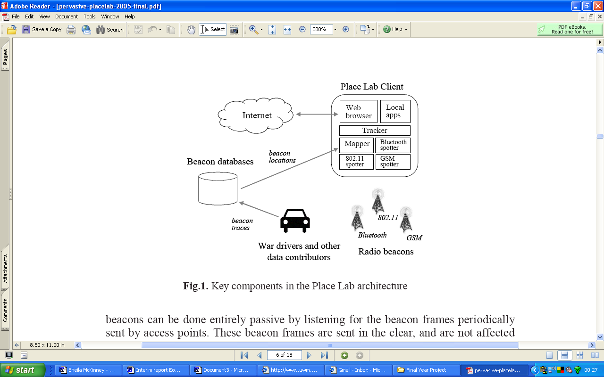
Figure 1: PlaceLab Architecture (LaMarca et al,. 2005)

2.2.1 Radio Beacons
PlaceLab operates by listening for transmissions from wireless networking devices such as 802.11 access points, GSM towers and fixed Bluetooth devices. These radio services are collectively referred to as beacons. Each of these are protocols that assign a unique or semi-unique ID to the beacons. Clients’ positions can be determined by detecting these ID’s. 802.11 access points can be used to determine location. The only interaction between the Access Point (AP) and the PlaceLab enabled device is that the device must detect the unique ID and the signal strength. PlaceLab does not require the client to transmit any data nor is it required to listen to any other network user’s transmission with 802.11. This is done entirely passively by listening for the beacon frames that are broadcast periodically by the AP. These frames are sent without any form of encryption and do not employ MAC address authorisation or WEP.

2.2.2 Beacon Databases

PlaceLab database information is contained in a flat text file with tab separated columns – Latitude, Longitude, SSID and BSSID. This file can be loaded into the PlaceLab database. The client must be able to ‘see’ a number of these access points to determine location. A minimum of three are required. Merely detecting on AP does not give our client its location. The relevant location information for the AP must be stored in the database. The database plays an essential role in the architecture of PlaceLab. It serves the clients with the beacons location information

2.2.3 PlaceLab Clients

The PlaceLab clients determine their location from both the database of APs and from making live observations of the radio signals around them. For reasons of portability and extensibility, the client’s functionality is divided into three separate elements: spotters, mappers and trackers.

Figure 2: Spotter Hierarchy

Spotters are the means by which the client observes the real physical world as shown in Figure 2. Other spotters may be used if necessary for the different protocols supported, for example, GSM and Bluetooth. The purpose of the spotter is to monitor the radio signals detected and pass on the ID’s of these beacons to other elements of the system. The mappers’ purpose is to provide the location of known radio beacons. Latitude and longitude are always provided but it is possible to include other relevant information such as altitude, power of the transmitter or the age of the current data. This data may come from a number of locations.

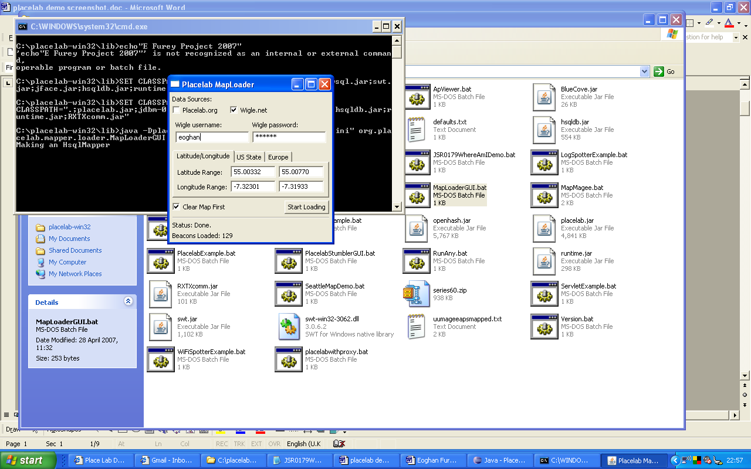

Figure 3: PlaceLab mapLoaderGUI interface with wigle.net

Wigle.com contains a mapping database for the cities in the United States and while such information is not commonly available in Ireland, a database does exist for the University of Ulster campus. The PlaceLab MapLoaderGUI is shown in Figure 3. 128 Beacons could be downloaded from this site for the Magee Campus. The accuracy of this database is however uncertain.
Figure 4: Tracker Hierarchy (LaMarca et al,. 2005)

The tracker is the “brains” of the system and it uses the information from the spotter and the mapper to estimate the client’s position. System understanding of signal propagation and its relationship to distance, location and the physical environment are encapsulated in the tracker. A simple tracker is included in PlaceLab that computes Venn diagram-like intersections of the beacons observed. Also included is a Bayesian particle filter tracker that uses range information for specific beacons. Although this requires more computation, it can give a 25% improvement in accuracy and can also give extra information like speed of movement and direction. Figure 4 shows a Tracker hierarchy diagram. A number of applications have been developed that use PlaceLab. Some of these have been developed by Intel Research and others by the PlaceLab user community.
While additional functionality is contained within PlaceLab to use GSM and Bluetooth signals, the high availability of 802.11 Wi-Fi Access Points means that this study will initially only consider these signals.

2.3 Positioning Algorithms

A number of different positioning algorithms may be used to determine position. These algorithms are used to translate various signal properties into angles and distances. This data is then subjected to various trigonometric functions to calculate position. Determining which algorithm to use depends on the given ranges and densities of Wi-Fi Access Points. Positioning algorithms may be divided into two main groups. The difference in these groups is that one group depends on an initial ‘training phase’ to create a more detailed ‘radio map’ of the area while the 2nd group does not require this phase. This training phase is used to improve the accuracy of the measurement. Algorithms that do not require this training phase include:

2.3.1 Cell ID based
This uses existing data from the network to identify which cell the user is in. It is mostly used in GSM networks where each area is known as a cell with the base station transmitter at the centre (Trevisani & Vitaletti, 2004).

2.3.2 Proximity/Closest Access Point (AP)
This is similar to Cell ID but is normally applies to Wi-Fi networks. A users’ location is given as that of the AP which it is communicating with. This is usually the strongest signal but may not always be the closest AP (Marsit et al., 2005).

2.3.3 Triangulation
All AP’s which can detect the signal of the mobile user respond to the network management system with the RSS (Received Signal Strength). The system then maps the coverage circles of each AP that can hear the user with circles representing the border of each AP’s signal strength. At least three APs are required. The location of the user is then estimated by applying triangulation algorithms which show the location of the user to be at the intersection of the circles (Gwon et al., 2004).

2.3.4 Trilateration
This is similar to triangulation except that instead of using angles, distances are used to perform the calculations. The position of the wireless device is determined as a function of the lengths between each detected AP and the mobile device. At least two (preferable more) APs in known positions must be able to detect the signal from the mobile device (Muthukrishnan et al., 2005). Because of the short wavelength of 802.11 Wi-Fi signals, Triangulation and Trilateration are seriously error prone due to a number of environmental issues with buildings and device interference (Kolodziej & Hjelm 2006). These factors affecting the accuracy indoors are: Attenuation: Reduction in RF signal strength as it passes through objects.; Occlusion: When RF signals are completely blocked by objects; Reflection: RF signals reflecting off objects making their paths to a sensor longer, hence giving a different reading.; Multipath: An RF signal can follow multiple paths to a sensor. This can result in different readings from the same sensor, even if the distances are the same. The following algorithms require an initial training phase:

2.3.5 Centroid
This is the simplest of all the positioning algorithms. The Users’ position is taken as the centre of all the detected APs. This is the basic method used in the PlaceLab software. In a study at the University of Ulster (Curran & Furey, 2007), the accuracy of this algorithm when combined with Wardriven data was found to be to be approximately 25m but this accuracy was only available 10% of the time.

2.3.6 Particle Filters
Particle filters are sophisticated model estimation techniques based on simulation. This probabilistic approximation implements a Bayes’ filter (Kolodziej & Hjelm, 2006). PlaceLab contains a particle filter. This technique requires two input models: a sensor model and a motion model. These are described by (Arulampalam et al., 2002). The sensor model estimates the probability that at a given location a given set of APs would be observed. The motion model then tries to move the particles in a manner that approximates the movements of the user.

2.3.7 Fingerprinting
This is the dominant technique used (Kolodziej & Hjelm, 2006). An a priori accomplished map is created by collecting signal sample points in the area. “Each sample point received contains the signal intensity and related map coordinates (Zlatanova & Verbree, 2003). The positioning accuracy achieved using this method in a Wi-Fi network is up to 1m (Retscher et al. 2007). Pahlavan and Li (2002) state that despite providing accurate positioning indoors, WLANS have problems with implementation because they require a reference database for average signal measurements at fixed points throughout a building.

2.3.8 Deterministic Techniques
Signal strength is taken as a scalar value. RADAR uses the nearest neighbour algorithm to infer location (Bahl et al., 2000).

2.3.9 Probabilistic Techniques
The information about the signal strength distributions from the AP’s is stored as a radio map and probabilistic techniques are used to estimate user location. An example of this is the Nibble System (Youssef & Agrawala, 2005) which uses a Bayesian network approach to estimate location. Research has shown that the probabilistic technique outperforms the deterministic technique (Kolodziej & Hjelm, 2006)

This study aims to improve upon the accuracy of these existing algorithms by including the history of movement of users in the test area. We will use probability functions along with this data to ‘predict’ the most likely location for regions of doubt, e.g.: which room a user is in or which floor they are on. This will be done by applying the signal strengths to maps/plans of the buildings to improve the overall accuracy. The University of Freiberg (Zhou, 2006) has shown that by using similar methods overall accuracy could be improved by 14.3% and estimations of the wrong room and wrong floor could be improved by 69.7% and 50% respectively.

2.4 Effective Isotropic Radiated Power (EIRP)

Tsoulos (1999) defines EIRP as “the radiated power from the antenna referenced to a theoretical point source”. A study by (Hubritch and Curran, 2007) has shown that when applied to GSM networks, taking the EIRP of the antenna into account can improve the median accuracy of the estimates by 71.3m over the accuracy of the Centroid algorithm. This study will take into account the EIRP of each of the Wi-Fi Access Points and will add this variable to the new algorithm to improve accuracy.

This literature review has looked at four main areas. First, an overview of some of the existing location estimation technologies has been carried out. This was followed by an overview of the PlaceLab software on which the algorithm will be run. Third, some of the existing location determination algorithms have been examined and finally EIRP has been defined and its relevance to this study explained.

3. Project proposal
The proposed project is the development of a new tracking algorithm which can be used within the PlaceLab framework. The new tracking algorithm will be able to track sources that are moving and will be able to differentiate between floors. It will make use of the new history based tracking algorithm and will take the Effective Radiated Power (ERP) of the Access Points into account. Figure 5 is divided into two parts. On the left it gives an overview of the project proposal. The diagram on the right shows how HABITS will still be able to calculate location when Line Of Sight (LOS) is not available to 3 Access Points(APs)

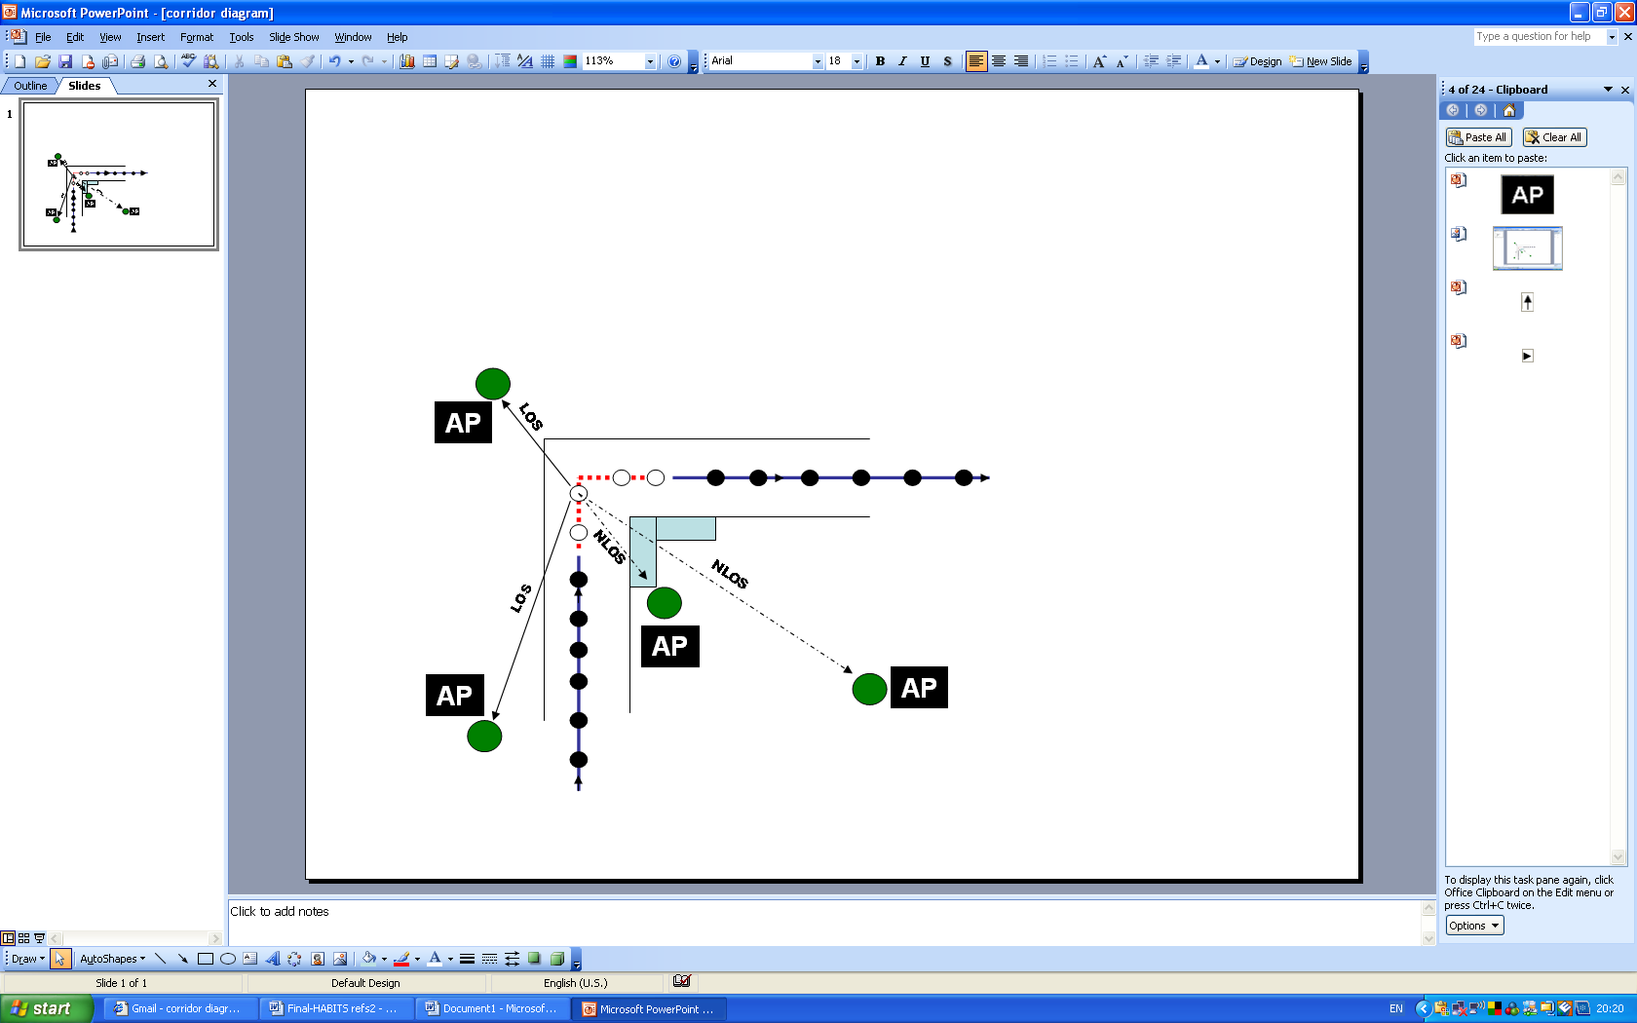
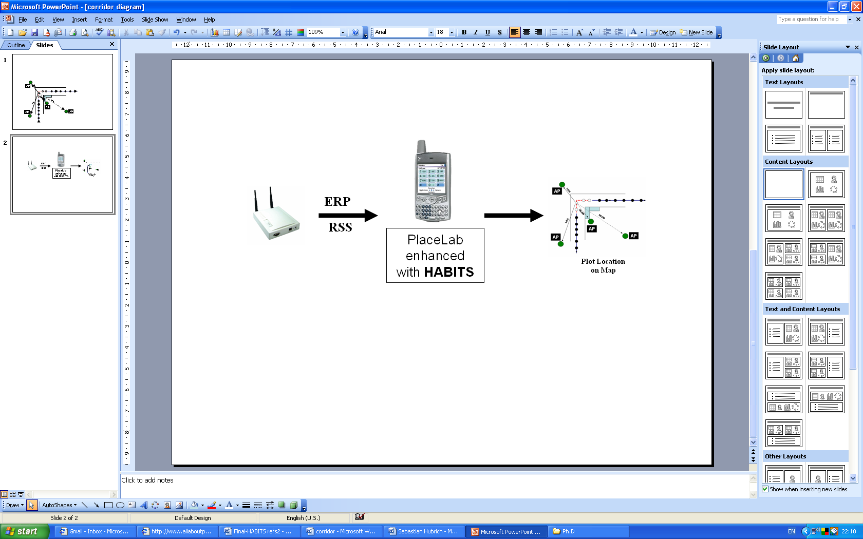

Figure 6: Project proposal Diagram and map showing where HABITS will be required.

3.1 Software Analysis and Prospective Tools

The newly developed algorithm will be tested from within the PlaceLab (LaMarca et al., 2005) software platform. This open source code will be manipulated from within the Eclipse (2007) IDE. The Wi-Fi signals will also need to be analysed using third party network analysing tools. Suitable Analysing tools include those created by Airmagnet (2007). Versions of these are available for both PDA and Laptop and it is anticipated that both of these will be required. For creation of the algorithm itself and for manipulation of the test data Matlab (2007) will be used. Additional Hardware that will be required for this study includes, extra Wireless NICs, a number of Access Points and Specific Omni directional Antennas. These are required it closely control the test environment.

4. Comparison to other work

Table A.1 in Appendix A compares the proposed HABITS Algorithm with existing Location Technologies and Applications. The table is divided into two parts. The first part considers various location technology hardware and the second considers some of the software systems that may be run on this hardware. Comparisons are made under various headings with the results shown in yellow being the desirable outcome. Considering the hardware options available, 802.11 Wi-Fi is the only indoor one listed with high levels of accuracy that doesn’t require specialised hardware and sensors to be installed. Along with RADAR and Ekahau, HABITS run on PlaceLab doesn’t require access to the Wi-Fi network that it is using. However, the combination of ERP and movement history means that HABITS will be more accurate and will give location estimations where the others cannot. This system can be used as the basis for future research. Table A.1 shows that while many of the other systems perform well on most of the comparisons, major obstacles such as the ability to work indoors, high levels of accuracy and cost make the HABITS system run on PlaceLab a clear improvement on existing approaches.

5. Project Schedule
Table B.1 in Appendix B outlines the plan of work for the completion of this project, together with an indication of the expected completion date for each of the tasks.

6. Conclusion
This research aims to advance knowledge by the development of a more accurate algorithm for Wi-Fi positioning in an Indoor environment. Here a basic review of existing location determination approaches has been carried out. The PlaceLab software platform, which will be the basis for this research has been outlined. A brief overview of some of the existing location detection algorithms has also been given along with a description of ERP. This will serve as a starting point on the journey to advance location pinpointing techniques through the development of the HABITS algorithm. This algorithm will use the history of movement of users through a building as a means of predicting the most likely paths that Wi-Fi enabled users may have travelled. This is necessary as many areas within buildings are RF signal black spots where traditional positioning techniques do not work. It will also consider the ERP of the access points as a means of increasing the accuracy of the algorithm. Potential software and hardware for this research has been identified. The HABITS algorithm has been shown to be the most attractive option when compared to other approaches. Movement history along with antenna EIRP has not been previously studied as a means of improving Wi-Fi indoor location estimates. This new algorithm will be tested in a creative technologies software application, where wireless self location is critical, such as mobile gaming, home automation & entertainment, tourist activity or security.

7. References
Addlesee, M., Curwen, R., Hodges, S., Newman, J., Steggles, P., Ward, A. & Hopper, A. 2001, "Implementing a sentient computing system", Computer, vol. 34, no. 8, pp. 50-56.
Airmagnet, 2007, www.airmagnet.com
Arulampalam, M., Maskell, S., Gordon, N., Clapp, T., Sci, D., Organ, T. & Adelaide, S. 2002, "A tutorial on particle filters for online nonlinear/non-GaussianBayesian tracking", Signal Processing, IEEE Transactions on [see also Acoustics, Speech, and Signal Processing, IEEE Transactions on], vol. 50, no. 2, pp. 174-188.
Ashbrook, D. & Starner, T. 2002, "Learning significant locations and predicting user movement with GPS", Wearable Computers, 2002.(ISWC 2002).Proceedings.Sixth International Symposium on, , pp. 101-108.
Badman, L. 2006, "Visualize your WLAN [Ekahau's Site Survey 2.2]", Network Computing, vol. 17, no. 16, pp. 38-9.
Bahl, P., Padmanabhan, V.N. & Balachandran, A. 2000, "Enhancements to the RADAR User Location and Tracking System", Microsoft Research, .
Bahl, P. & Padmanabhan, V.N. 2000, "RADAR: an in-building RF-based user location and tracking system", INFOCOM 2000. Nineteenth Annual Joint Conference of the IEEE Computer and Communications Societies. Proceedings. IEEE, pp. 775.
Benford, S. 2005, "Future Location-Based Experiences", JISC Technology and Standards Watch.Available at: http://www, jisc.ac.uk/techwatch, .
Brown, B., MacColl, I., Chalmers, M., Galani, A., Randell, C. & Steed, A. 2005, "Lessons From The Lighthouse: Collaboration In A Shared Mixed Reality System", Proceedings of the SIGCHI Conference on Human Factors in Computing SystemsACM, New York, NY.
Curran, K. & Furey, E. 2007, "Pinpointing Users with Location Estimation Techniques and Wi-Fi Hotspot Technology", International Journal of Network Management, vol. 16, no. 6.
Dodson, A.H., Shardlow, P.J., Hubbard, L.C.M., Elgered, G. & Jarlemark, P.O.J. 1996, "Wet tropospheric effects on precise relative GPS height determination", Journal of Geodesy, vol. 70, no. 4, pp. 188-202.
Eclipse, 2007, www.eclipse.org
Ekahau, 2007, www.ekahau.com
Flynn, P., Lunney, T. & McKevitt, P. 2004, Resource Allocation Mobility Location Prediction Model (RAMLPM), University of Ulster,.
Geer, D. 2001, ‘The E911 dilemma’.
Goyal, S. 2005, "WMCSA 2004: 10 Years of Mobile and Ubiquitous Computing", Pervasive Computing, IEEE, vol. 4, no. 2, pp. 88-90.
Gwon, Y., Jain, R. & Kawahara, T. 2004, "Robust indoor location estimation of stationary and mobile users", INFOCOM 2004. Twenty-third AnnualJoint Conference of the IEEE Computer and Communications Societies, pp. 1032.
Hazas, M., Scott, J. & Krumm, J. 2004, "Location-aware computing comes of age", Computer, vol. 37, no. 2, pp. 95-97.
Hubrich, S. & Curran, K. 2007, Optimizing Mobile Phone Self-Location Estimates by Introducing Beacon Characteristics to the Algorithm, Masters edn, Open University.
Kato, H., Billinghurst, M., Poupyrev, I., Imamoto, K. & Tachibana, K. 2000, "Virtual object manipulation on a table-top AR environment", Augmented Reality, 2000. (ISAR 2000). Proceedings. IEEE and ACM International Symposium on, pp. 111.
Kolodziej, K.W. & Hjelm, J. 2006, Local Positioning Systems: LBS Applications and Services, CRC Press.
Krumm, J., Cermak, G. & Horvitz, E. 2003, RightSPOT: A Novel Sense of Location for a Smart Personal Object.
LaMarca, A., Chawathe, Y., Consolvo, S., Hightower, J., Smith, I., Scott, J., Sohn, T., Howard, J., Hughes, J., Potter, F., Tabert, J., Powledge, P., Borriello, G. & Schilit, B. 2005, "Place Lab: device positioning using radio beacons in the wild", ProceedingsSpringer-Verlag, Munich, Germany, pp. 116.
Marsit, N., Hameurlain, A., Mammeri, Z. & Morvan, F. 2005, "Query processing in mobile environments: a survey and open problems", Distributed Frameworks for Multimedia Applications, 2005. DFMA '05. First International Conference on, pp. 150.
Mathlab, 2007, www.mathworks.com
Muthukrishnan, K., Lijding, M. & Havinga, P. 2005, Towards Smart Surroundings: Enabling Techniques and Technologies for Localization, Springer.
Pahlavan, K., Li, X. & Makela, J.P. 2002, "Indoor geolocation science and technology", Communications Magazine, IEEE, vol. 40, no. 2, pp. 112-118.
Randell, C. & Muller, H. 2001, "Low Cost Indoor Positioning System", Ubicomp 2001: Ubiquitous Computing: International Coference, Atlanta, Georgia, USA, September 30-October 2, 2001: Proceedings, .
Retscher, G., Moser, E., Vredeveld, D., Heberling, D. & Pamp, J. 2007, "Performance and accuracy test of a WiFi indoor positioning system", JOURNAL OF APPLIED GEODESY, vol. 1, no. 2, pp. 103.
Smith, I., Scott, J., Sohn, T., Howard, J., Hughes, J., Potter, F., LaMarca, A., Chawathe, Y., Consolvo, S. & Hightower, J. 2005, "Place Lab: Device Positioning Using Radio Beacons in the Wild", Pervasive Computing: Third International Conference, Pervasive 2005, Munich, Germany, May 8-13, 2005, Proceedings,
Smith, I. 2005, "Social-mobile applications", Computer, vol. 38, no. 4, pp. 84-85.
Thrall, G.I. & Thrall, S.E. 2000, "MapPoint and Maptitude Destinations Known", Geospatial Solutions, , pp. 47-49.
Trapeze, 2007, www.trapezenetworks.com
Trevisani, E. & Vitaletti, A. 2004, "Cell-ID location technique, limits and benefits: an experimental study", Mobile Computing Systems and Applications, 2004. WMCSA 2004. Sixth IEEE Workshop on, pp. 51.
Tsoulos, G.V. 1999, "Smart antennas for mobile communication systems: benefits and challenges", Electronics & Communication Engineering Journal, vol. 11, no. 2, pp. 84-94.
Youssef, M. & Agrawala, A. 2005, "The Horus WLAN Location Determination System", Proc.of ACM Mobisys, .
Zhou, R. 2006, "Enhanced wireless indoor tracking system in multi-floor buildings with location prediction",
Conference Eunis 2006.
Zlatanova, S. & Verbree, E. 2003, "Technological Developments within 3D Location-based Services", International Symposium and Exhibition on Geoinformation, , pp. 13-14.

Appendix A: Comparison of Location Technology and Applications

Category | System | Year | Indoor | Cost | Potential for Interference | Resolution Accuracy | Position determination by device | 802.11 | Calibration required
Location Technology | GPS | 1970s | ^{No} | ^{Low} | ^{Low} | ^{High} | ^{Yes} | ^{No} | ^{No}
Location Technology | RFID |  | ^{Yes} | ^{High} | ^{High} | ^{High} | ^{No} | ^{No} | ^{Yes}
Location Technology | Infrared |  | ^{Yes} | ^{High} | ^{High} | ^{High} | ^{Yes} | ^{No} | ^{Yes}
Location Technology | Ultrasonic Time of Flight |  | ^{Yes} | ^{High} | ^{Low} | ^{High} | ^{No} | ^{No} | ^{Yes}
Location Technology | Bluetooth | 1994 | ^{Yes} | ^{Low} | ^{Low} | ^{High} | ^{Yes} | ^{No} | ^{Yes}
Location Technology | Inertia Tracking |  | ^{Yes} | ^{High} | ^{Low} | ^{High} | ^{No} | ^{No} | ^{Yes}
Location Technology | GSM | 1980s | ^{Yes} | ^{Low} | ^{High} | ^{Low} | ^{No} | ^{No}
Location Applications | RADAR(Wi-Fi) | 2000 | ^{Yes} | ^{High} | ^{Low} | ^{High} | ^{Yes} | ^{Yes} | ^{Yes}
Location Applications | Cricket(Ultrasound) | 2000 | ^{Yes} | ^{High} | ^{Low} | ^{High} | ^{Yes} | ^{Yes} | ^{Yes}
Location Applications | Ekahau(Wi-Fi) | 2002 | ^{Yes} | ^{High} | ^{Low} | ^{High} | ^{No} | ^{Yes} | ^{Yes}
Location Applications | RightSPOT(FM radio) | 2003 | ^{No} | ^{Low} | ^{High} | ^{Low} | ^{Yes} | ^{No} | ^{No}
Location Applications | LA-200(Trapeze-Wi-Fi) | 2007 | ^{Yes} | ^{High} | ^{Low} | ^{High} | ^{No} | ^{Yes} | ^{No}
Location Applications | PlaceLab(Wi-Fi) | 2004 | ^{Yes} | ^{Low} | ^{Low} | ^{Low} | ^{Yes} | ^{Yes} | ^{No}
This Project | HABITS(Run on PlaceLab) | 2007 | ^{Yes} | ^{Low} | ^{Low} | ^{High} | ^{Yes} | ^{Yes} | ^{Yes}

Table A.1: Comparison of other Location Technologies and Applications

Appendix B
Activities
Submissions
Deliverables

Research Activities | 2007 | 2008 |  |  |  | 2009 |  |  |  | 2010
 | Nov-Dec | Jan-Mar | Apr-Jun | Jul- Sep | Oct- Dec | Jan- Mar | Apr-Jun | Jul-Sep | Oct-Dec | Jan-Mar | Apr-Jun | Jul-Oct
Perform Literature Review

100 Day Review and Presentation

Perform In-depth Review of Existing Location Algorithms

Study of Advanced Probability and Statistical Methods

Selection of Tools for use and design of test environment
Submission to IT & T 2008 Conference
(Approx Apr-May 2008, submission dates TBA)
Submission to UbiComp 2008 Conference
(Approx Sept-Nov 2008, submission dates TBA)
Confirmation

Formulate new algorithm and test

Refine new algorithm and test
Create creative technologies application to demonstrate algorithm

Test and Evaluate

Submission to IEEE Pervasive Computing Journal

Submission to IEEE Transactions on Wireless Computing Journal
Thesis write up

Table B.1: Plan of Proposed Research Schedule

